Lets learn how to work with async actions with rtk.
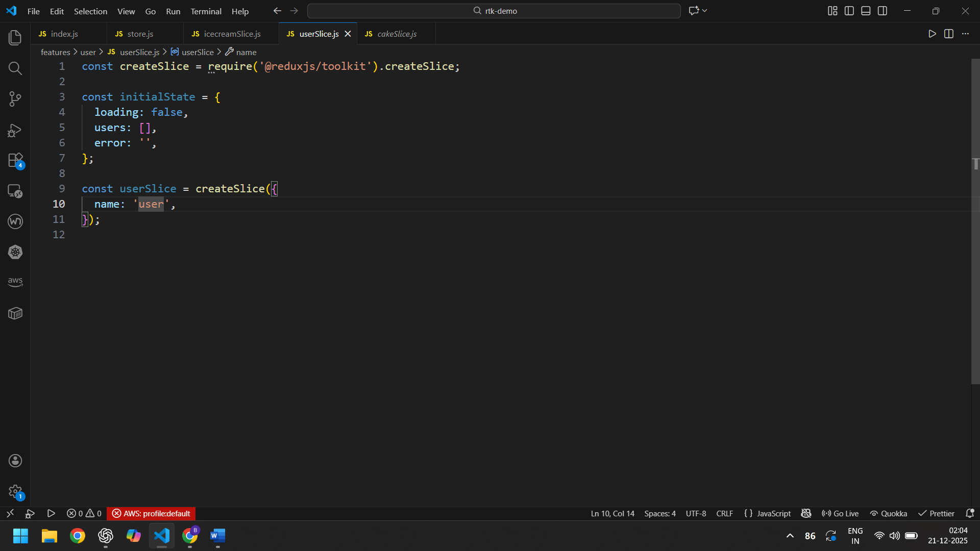
RTK PROVIDES CREATEASYNCTHUNK FUNCTION TO IMPLEMENT THE CREATION AND DISPATCHING OF ASYNC ACTIONS.
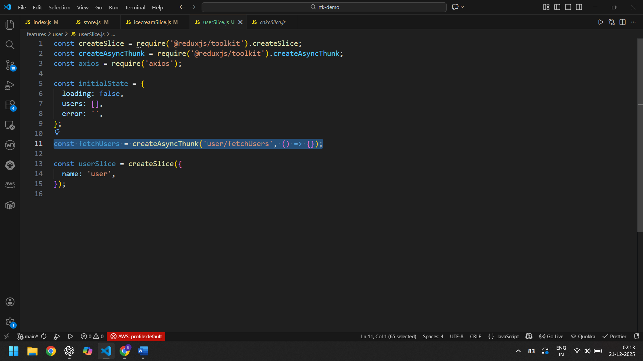
createAsyncThunk IS CALLED OUTSIDE THE SLICE. The createAsyncThunk TAKES IN TWO ARGUMENTS – ACTION TYPE, A CALLBACK FUNCTION THAT CREATES THE PAYLOAD.
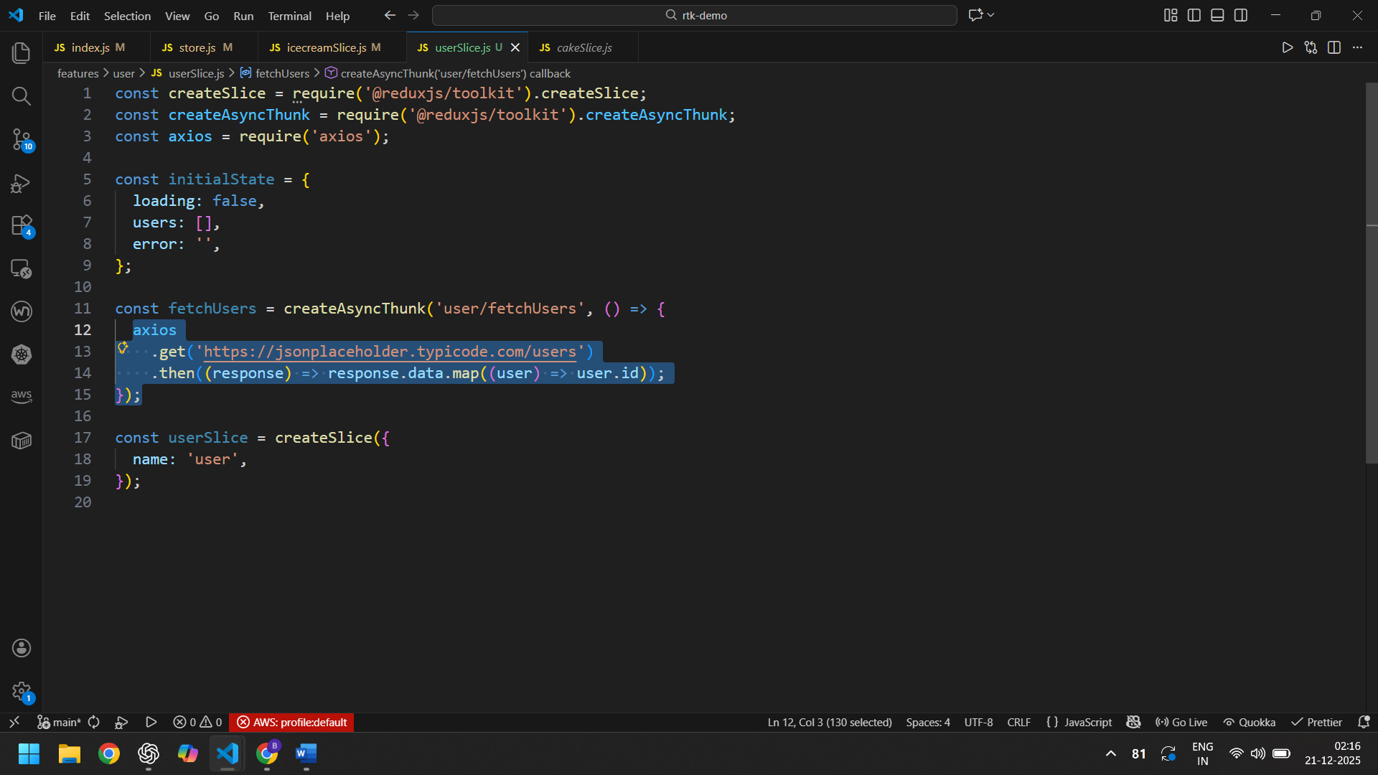
WE DON’T NEED CATCH BLOCK AS ERROR IS HANDLED
HERE IS THE SPECIAL FUNCTIONALITY OF CREATE ASYNC THUNK. IT WILL AUTOMATICALLY DISPATCH LIFE CYCLE ACTIONS BASED ON THE RETURNED PROMISE. A PROMISE IS EITHER PENDING, REJECTED OR FU,FULFILLED.
createAsyncThunk generates Pending, Fulfilled and Rejected action types
WE CAN LISTEN TO THESE ACTION TYPES AND PERFORM NECESSARY STATE TRANSITIONS. THE REDUCERS THOUGH ARE NOT GENERATED BY SLICE AND HAVE TO BE ADDED AS EXTRA REDUCERS.
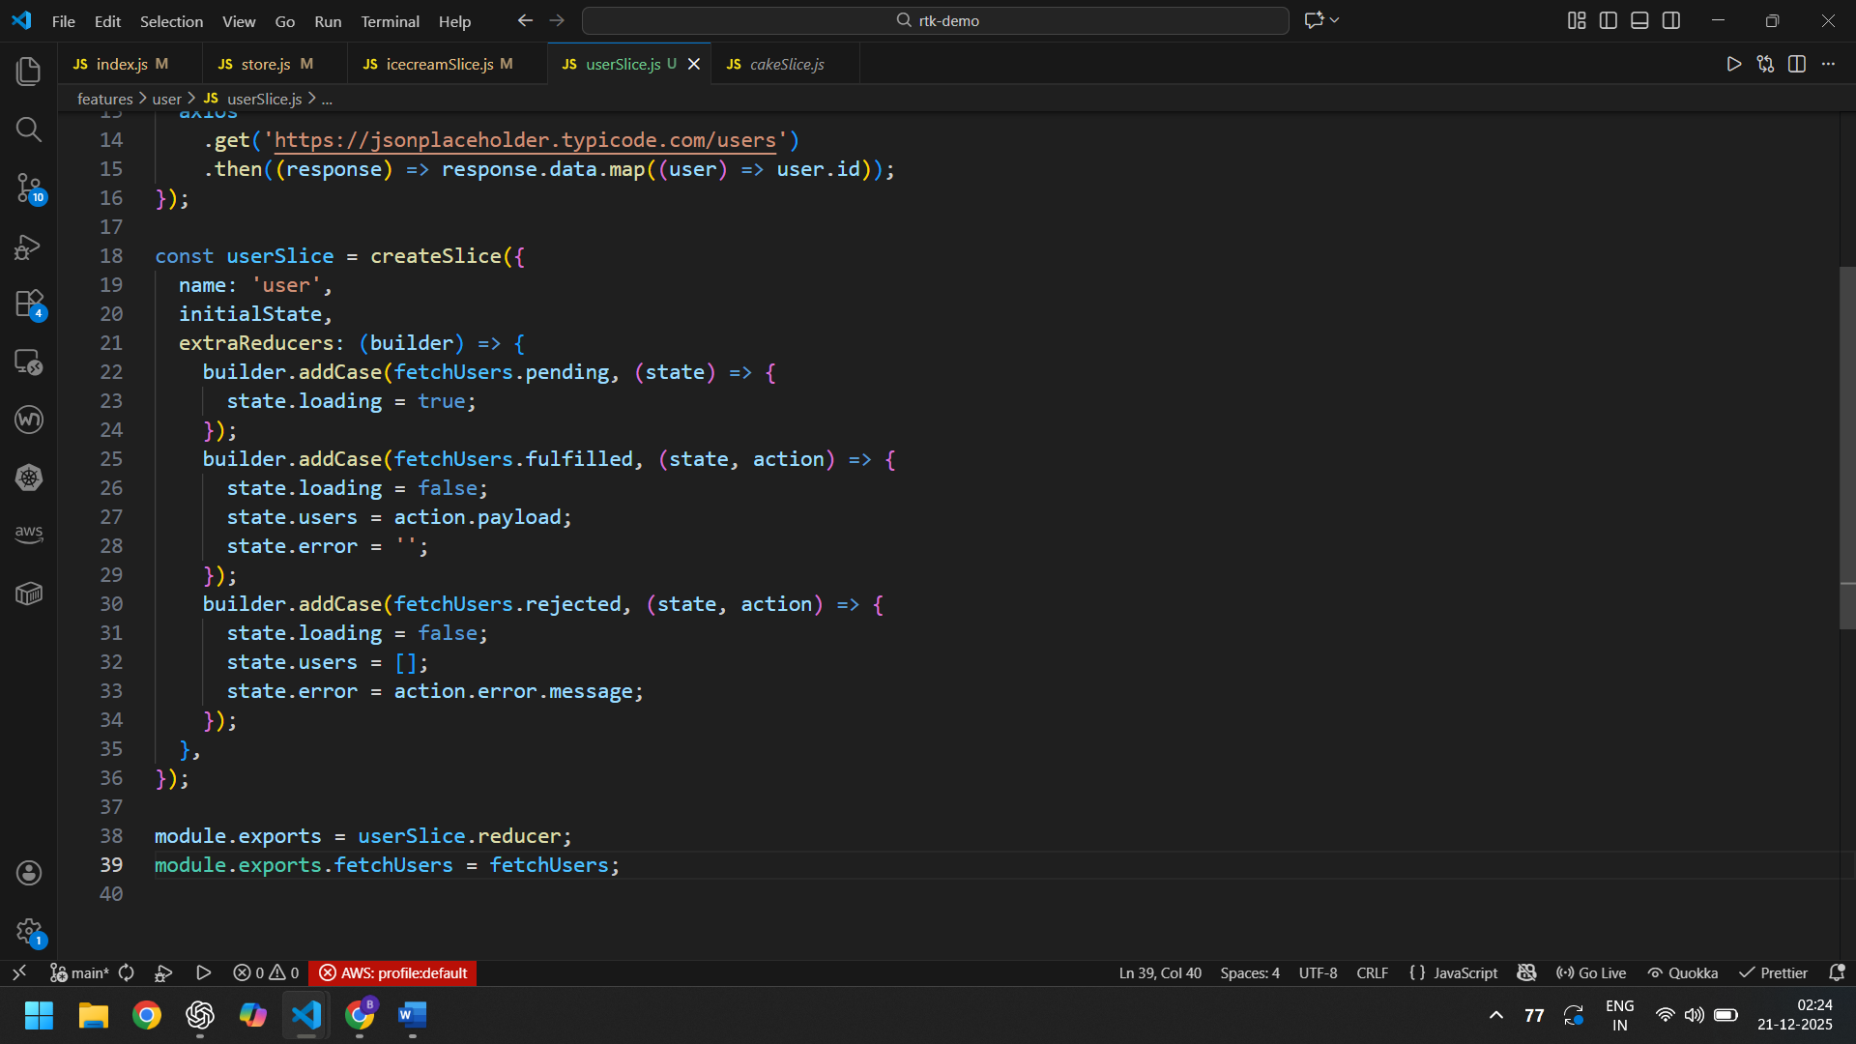
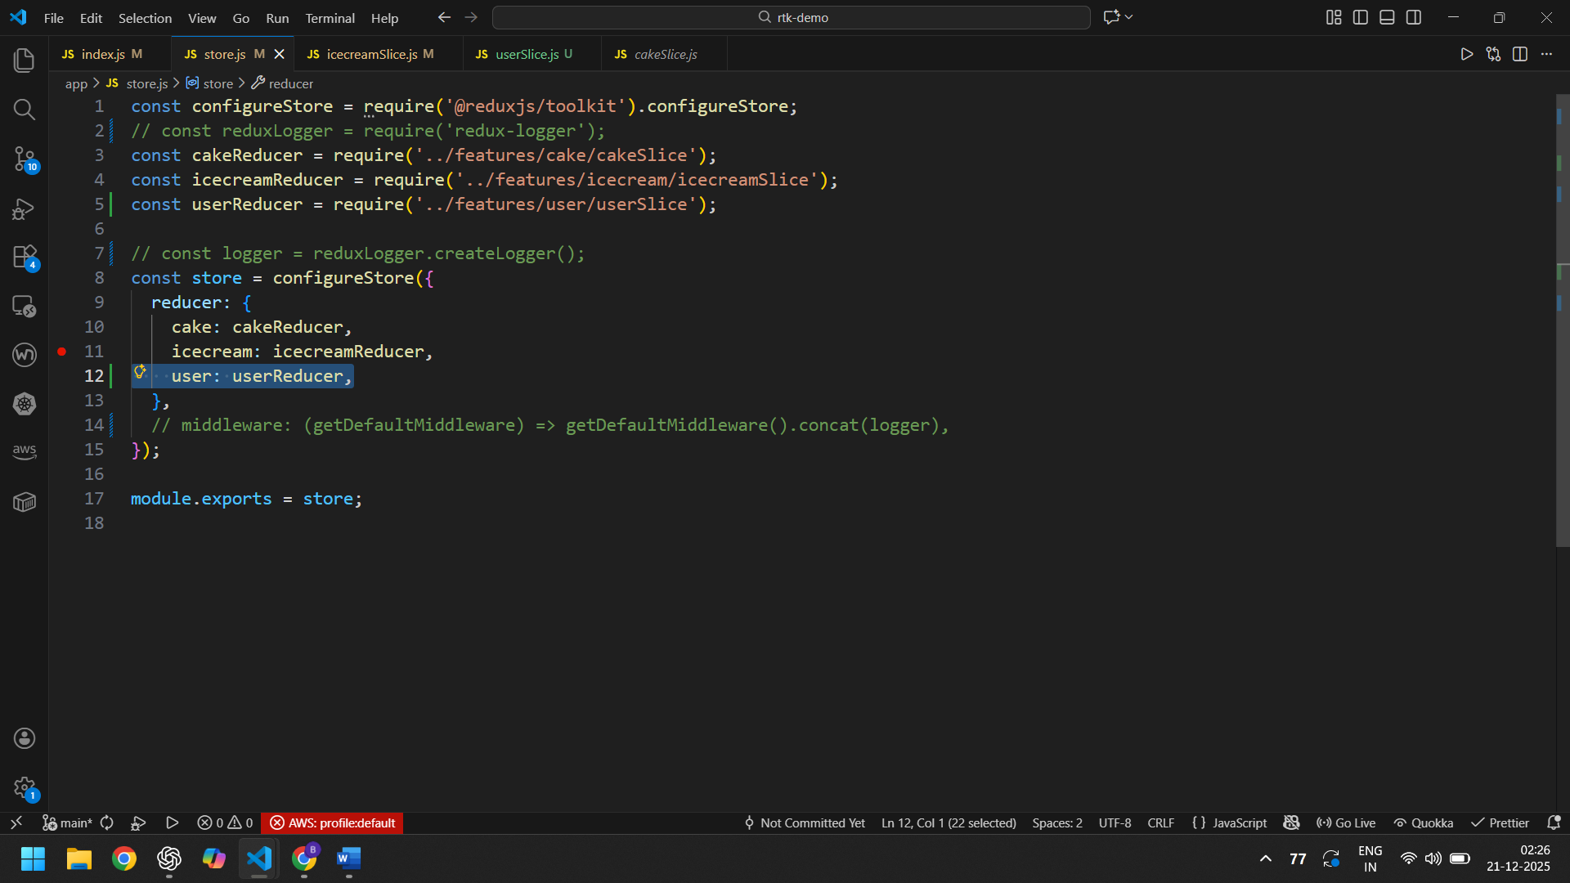

createAsyncThunk UNDER THE HOOD MAKES USE OF REDUX THUNK LIBRARY. REDUX THUNK IS APPLIED AS A MIDDLEWARE TO THE STORE UNDER THE HOOD. EVERYTHING IS ABSTRACTED BY RTK.

